**Long Buckby Practice  
Patient Newsletter**

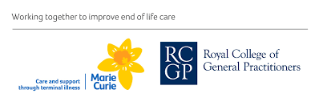**Autumn 2024**

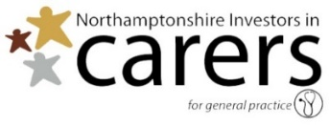

**www.longbuckbypractice.nhs.uk**

**The Practice is open Monday to Friday 8am to 6.30pm. Closed on Bank Holidays.   
Appointments are now available up to 8pm on weekday evenings and Saturday 9am to 5pm.   
These could be at another local practice.**

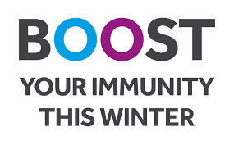You may have seen on the television, the press or social media about a new vaccine called the **RSV** **(respiratory syncytial virus) vaccine.** From 1 September 2024, patients who turn 75 and those age 75 to 79 are eligible for a free vaccine to protect them from RSV.

RSV is an infectious disease of the airways and lungs. RSV infection often causes symptoms like a cold, including cough, sore throat, sneezing and a runny or blocked nose. It can also make you become wheezy or short of breath and lead to pneumonia and other life-threatening conditions. Every year thousands of older adults need hospital care for RSV, and some of them will die. RSV can be more severe in people with medical conditions such as heart or lung disease or a weakened immune system.

RSV infection is common in young children but is most serious for small babies and for older people which is why 75 – 79 year olds and pregnant women are offered the vaccine. Pregnant women get their vaccine at the hospital but if you are in the age range, please ring reception on 013247 842360 to book an appointment or to tell us if you don’t want one.

From the 3rd October you will be also be able to have a **flu jab**. If you are over 65, pregnant or have a chronic disease please ring reception to book your appointment, or again, to tell us you don’t require one this season.

**Long Buckby Practice now has a Facebook page. Please follow us for health and surgery information.**

Lastly, but not least, a **covid booster** will be available to eligible patients. You can get this vaccine at participating pharmacies and walk in centres.

**Our Telephone System**

If you press the correct option when telephoning us, you will get to talk to the correct member of staff quicker.

**Option 1** – To make all appointments.

**Option 2** – To cancel your appointment.

**Option 3** – For medication queries and to order your repeat prescription if you cannot use The NHS App. This line is available 8.30am- 10.30am and 5.30pm- 6pm only.

**Option 4** – To obtain your test results if you can not use the NHS App.   
This line is open 11am- 6.30pm only.

**Option 5** – To contact administration. This is for matters such as insurance reports, new patients, change of addresses, records queries, or to contact Our Carers’ Lead. You can leave a message on this line, and we will return your call as soon as possible.

**Option 6** – To contact the Secretary regarding any hospital queries. Please note that the secretaries cannot deal with medication queries. You can leave a message on this line, and we will return your call as soon as possible.

**Blood Pressure and Asthma Monitoring**

If you have been into the surgery recently you will have noticed that we now have a blood pressure machine you can use yourself. Whether a clinician has asked you to submit your BP reading, or you just want to know your BP, just follow the instructions on the wall – it’s very easy to use.

Once you have taken your blood pressure and received the print out, please put your full name and date of birth on the top and hand to the receptionist.

If your BP is higher than 170/115, please make the receptionist aware and do not leave the building until the receptionist has notified a clinician.

We may contact you asking you to submit a BP reading instead of making an appointment at the blood pressure clinic.

If you come to the asthma clinic, we may contact you asking you to fill in a questionnaire via an app called Anima. You will need to register online with Anima the first time to do this,

Of course, if you feel you still need to see a clinician, please make an appointment in the usual way.

Our phonelines are busiest between 8am and 10am. If you don’t need a same day appointment, please consider ringing later in the day on 01327 842360. Thank you.